RVDC LEARNING MANAGEMENT SYSTEM
S. No. | I-BDS Session Topic and Faculty details | YouTube link
1 | Salivary Glands- Dr.Suma 2nd April I BDS | https://youtu.be/-_Y5SF9V-hA
2 | Permanent Maxillary First Molars - Dr Sarita 24th March I BDS | https://youtu.be/TcD8y5KFgLo
3 | Olfactory Nerve Dr Bhagyalakshmi 4th April I BDS | https://youtu.be/sNeXCgmWVK0
4 | Mineral Metabolism(Biochemistry) - Dr Vaishali 27th March I BDS | https://youtu.be/EbRC2108lM0
5 | Facial Nerve Dr Bhagyalakshmi 4th April I BDS | https://youtu.be/H1HUtL-t-pk
6 | Descending Tracts 31st March I BDS | https://youtu.be/Cw97nD2bpuM
7 | Cranial Nerve Nuclei-Dr.Bhagyalakshmi 31st March I BDS | https://youtu.be/877rWj9Fa8w
8 | I BDS Physiology Dr Preethi Whiteboard class | https://youtu.be/w6TMtQ-Fu70

S. No. | II-BDS Session Topic and Faculty details | YouTube link
1 | Rhinosporiodosis 2nd March II BDS | https://youtu.be/8cXReI0_yrE
2 | Mycology 31st March II BDS | https://youtu.be/S3tv7Be9JS4
3 | Leishmania - Dr.Kavyashree 9th April 2020 II BDS | https://youtu.be/kZA-ZFvtRjA
4 | Lecture by Dr Murali 27th March II BDS | https://youtu.be/Ev_Q6EimjCY
5 | Emetic and Antiemetic - Dr Veena 4th April II BDS | https://youtu.be/mC8GjNQX_9k
6 | Amebiasis - Dr Kayvashree II BDS | https://youtu.be/5s5vfneyA9s
7 | Disorder of RBCs - Dr.Bharathi 4th April II BDS | https://youtu.be/YDcwywOg9-c
8 | Dr Veena's Lecture II BDS 04042020 | https://youtu.be/eBzOcYqj72g

S. No. | III-BDS Session Topic and Faculty details | YouTube link
1 | White Sponge Nevus III Bds May 4, 2020 | https://youtu.be/zvFakSjjNrs
2 | Waste management Dr Jyothsana III Bds Mar 23, 2020 | https://youtu.be/1xjuZvjCmu4
3 | Trigeminal Neuralgia III Bds Apr 04, 2020 2 | https://youtu.be/Uf9hUUGwPNQ
4 | Skin Disorders III Bds Apr 30, 2020 | https://youtu.be/G0PArlsW-3E
5 | Radiology Dr Revan III Bds Apr 26, 2020 | https://youtu.be/0WkIrfYU754
6 | Pathopysiology III Bds Apr 15, 2020 | https://youtu.be/N2xPDRXX58I
7 | Oral Cancer Dr Deepthi III Bds Mar 26, 2020 | https://youtu.be/2AY1UU9Zei0
8 | Lymphoma III Bds Apr 08, 2020 1 | https://youtu.be/eabYI-jWTzk
9 | Infectious Diseases Dr Madhura III Bds Mar 28, 2020 | https://youtu.be/LOQOl-jxzdQ
10 | Infection Control Dr Revan III Bds Mar 30, 2020 | https://youtu.be/01TVHVYSqLo
11 | Immune Mediated Mucocutaneous Dieseases III Bds May 8, 2020 | https://youtu.be/R7Nooo7TzC0
12 | Genetic Bone Disorders Dr Madhura III Bds Apr 16, 2020 | https://youtu.be/_qYyRO9qLbM
13 | Dyskeratosis Congenita III Bds May 7, 2020 | https://youtu.be/jD2kLWcDVg0
14 | Candediasis Dr Suma III Bds Mar 30, 2020 | https://youtu.be/4MYO82bq5s0
15 | Bone Disorders III Bds Apr 13, 2020 | https://youtu.be/q305Sx9Cpuw
16 | Balanced Diet III Bds Apr 08, 2020 2 | https://youtu.be/jlIn0iEGAOQ
17 | Discussion on COVID 19 III Bds Apr 04, 2020 1 | https://youtu.be/iuai0W4VPfU
18 | Dr Suma Fungal Infections III BDS | https://youtu.be/kbo-Ngc0BXM

S. No. | IV-BDS Session Topic and Faculty details | YouTube link
1 | Supportive Periodontal Therapy 1st April IV BDS | https://youtu.be/aS6-xpr3EQw
2 | Oral Cancer 28th March IV BDS | https://youtu.be/BJxYmFy-Ljg
3 | Oral Cancer 1st April IV BDS | https://youtu.be/xHzcqcKdxuw
4 | Lecture by Dr Murali 23rd March IV BDS | https://youtu.be/clE9QIbwLSY
5 | Lecture by Dr Murali 15th April | https://youtu.be/YG3jtsoQOBI
6 | LASER - Dr Murli 30th March IV BDS | https://youtu.be/c_wpDg91exQ
7 | Gingival Enlargement Dr Divya 28th March IV BDS | https://youtu.be/AfPzfXuvXHI
8 | Cerebral Palsy Dr Pratibha 30th March IV BDS | https://youtu.be/3O443XRAmA0
9 | Biostatistics Dr Jyothsna 8th April IV BDS | https://youtu.be/AnTDFnfhUnE

RVDC LEARNING MANAGEMENT SYSTEM ACCESS

Quiklrn Login ID - library.rvdc@rvei.edu.in
Password – rvdc12345

How to download the Learning material

- Download the Quiklrn App from this link: https://quiklrn.com/app.php ( from Android/iOS devices or Windows 10 laptop)

- Login to the App with your ID and Password

- Click on the relevant book under the "Recommendation tab."

- Click on the orange "Download button" to download the eBook. (Allow the book to get completely downloaded. It may take a few (3-7) minutes, depending on the network speed for the book to download fully.

- Once it is downloaded, it will show as "Open," click on it to open the book and start exploring.

How to see all the learning material course wise

Step 1 – Click on the purple Recommended button

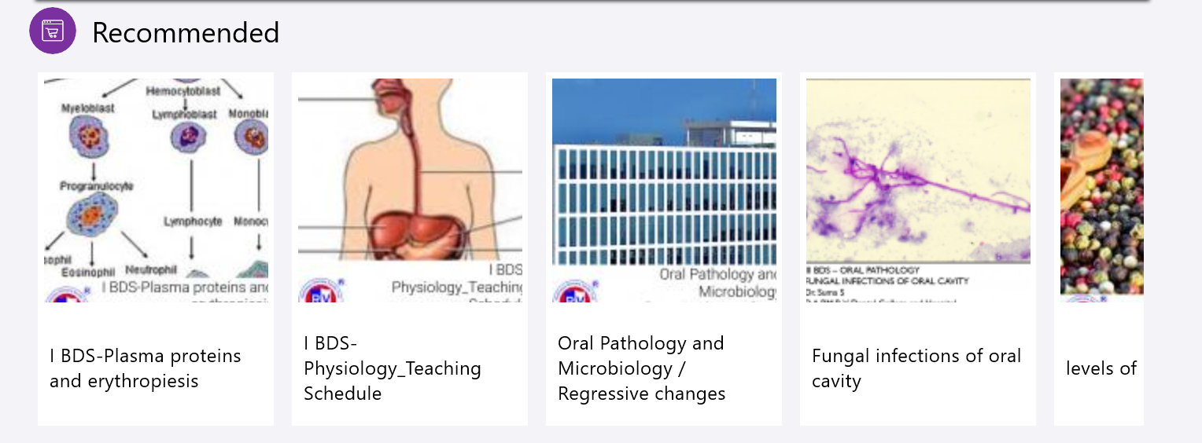

Step 2 – Quiklrn store opens with course wise content, class video recordings, and Textbooks as depicted in the picture below. Click on any of the contents to download it.
RVDC Content store
